Schaumburg Professional Firefighter’s Association Presents: Schaumburg Firefighters Fighting Cancer: 5th Annual Pink Tie Ball!
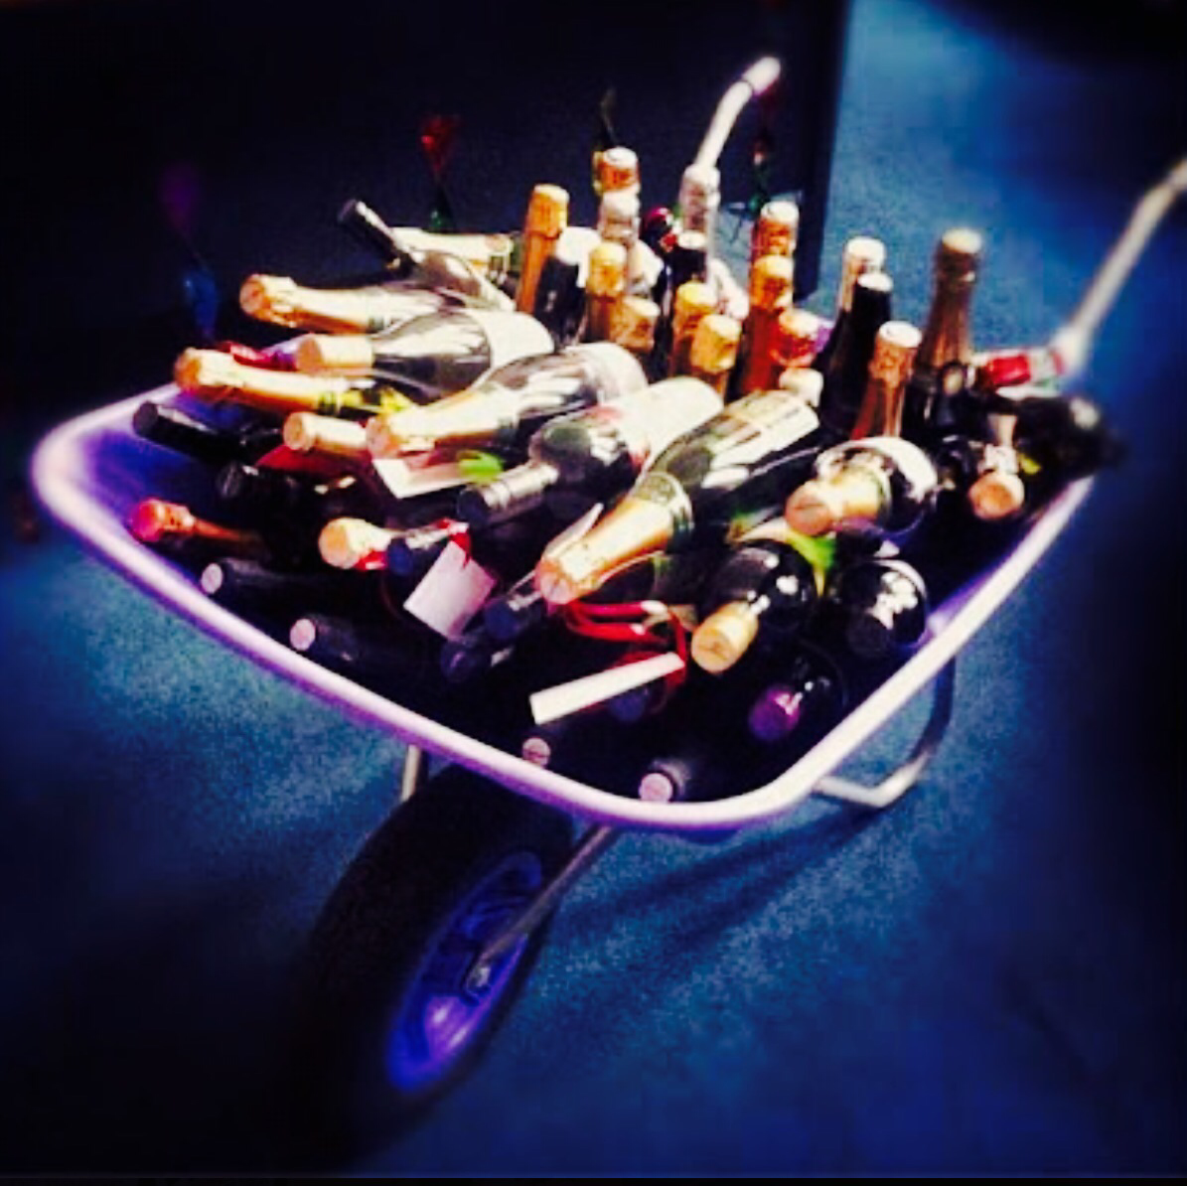
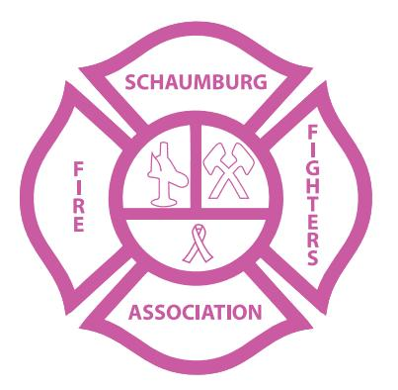
2016 Pink Tie Ball’s: BOOZE WHEEL BARROW Donation
The Schaumburg Professional Firefighter’s Association: Firefighters Fighting Cancer Committee’s “Booze Barrel Raffle” is asking you or your company to partner with the Schaumburg Firefighters Fighting Cancer to help promote the fight against cancer and raise money for the cause. We cordially want to invite your company to become one of our cherished sponsors, and in doing so we are asking for an alcohol donation, to add to our “Booze Wheel Barrow” grand prize raffle. We are looking for any type of liquor donation, with hopes of making this raffle prize one of our most coveted items, sought after by all 550+ attendees. Additionally, all of the companies who choose to donate liquor for the Pink Tie Ball “Booze Barrow,” will also be represented on a banner, to be hung at the venue, in the ballroom, the evening of the Pink Tie Ball. This partnership, between your company and the Schaumburg Firefighters Fighting Cancer will not only help raise funds, but will help the overall awareness project in our community and many surrounding communities combat cancer, fund cancer research, but will assist with the overall personal health and wellness of those battling cancer. This donation will show the public that your company is one of the few, one of the charitable companies out there that is truly trying to help bring an end to this vicious disease! One hundred percent of monies raised from our “Booze Barrow” will be donated to the National Cancer Research Institute, specifically earmarked for cancer research and the Alexian Brothers Cancer Institute, benefiting those currently being treated for cancer within and around our communities. Federal Tax ID #E9923-1212-01.
If interested in making a Liquor Donation? Please contact the Schaumburg Firefighters Fighting Cancer at pinktieball4092@gmail.com or call 312.841.1122.

